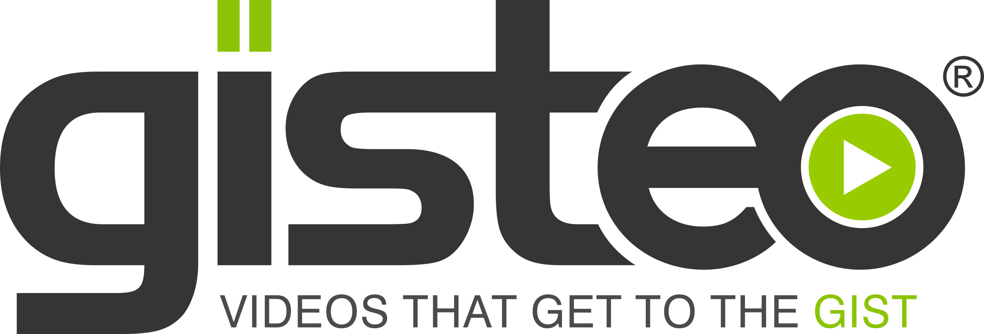

Pre-Production Questionnaire

Note: upon completion, please send this document to us at info@gisteo.com. We’ll be in touch with lightning-fast speed to set up a time to discuss.

- Why are you having this video created and what do you hope to accomplish?

- Briefly describe what your company, product or service does:

- Who are your main competitors? Please list website url’s for reference if possible.

- What separates you from your competitors? What makes you unique (or what will make you unique when you launch)?

- Take us inside the mind of your target customer. Please describe them not only in demographic terms but also in terms of what motivates them, what keeps them up at night, what barriers/”pain points” they might currently be facing that could lead them to need a product or service like yours, etc.

- How is your brand making their life better? How do you address the above mentioned barriers and pain points of your target, especially in comparison to other offerings out there?

- What do you want the main takeaways to be after people watch this video (don’t list every single point that may be covered, instead list the key takeaways that you need to stick with people after seeing this)?

- Any “do’s and don’ts” in terms of the video? Eg tonality to either use or avoid, certain buzzwords to focus on or avoid, etc?

- Do you have call-to-action that you’d like to include (eg call, click here, sign up…)?

- Any brand tagline or slogan that you’d like to include at the end of the video?

- Do you have a specific running time/length in mind (60 seconds, 90 seconds etc.)?

- Are there any videos or styles that you would like to emulate in this production? Please provide specific links. Note, the links could be from either Gisteo (see our Vimeo channel for more examples www.vimeo.com/channels/gisteo) or from other videos you’ve seen online.

